Face Recognition Unlocking System
Esteemed Guidance of JeyaRam Sir (ED)

INTRO:

The face recognition system is part of facial image processing applications and it is one of the challenging topics in IT research. Biometric information of humans is used instead of a fingerprint, iris, signature, etc. because these types of biometrics are not much suitable for non- collaborative people. Face recognition systems are usually used and preferred for the security cameras in metropolitan life. These systems can be used for crime prevention, video surveillance, person verification, and similar security activities.

Face detection is the first step of the face recognition system. The output of the detection is the location of a face region with facial features (i.e., eyes, mouth, eyebrows, nose, etc). Detection methods are classified into two groups as knowledge-based methods and image-based methods.

AIM:

To improve the security system with AI (Artificial Intelligence) we aimed to build a FACE LOCKING SYSTEM, where a door will be locked and unlocked through the face. To achieve the need full we have worked on python 3, to build a source code and perform operations after recognizing.

OBJECTIVE:

Face detection and face recognition describes an efficient algorithm using an open-source image processing framework known as Opencv and Dlib. It is used for image processing applications to load the images into the system and process the images. Our approach has four modules – Face Detection, Face Preprocessing, Face Training and Face Recognition.

The system is initially trained with the faces which are collectively known as a database. The system uses user-friendly interface to maximize the user experience while both training and testing which are collecting single images and detecting them.

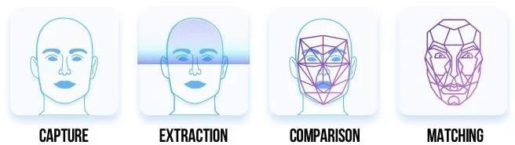

PROPOSED WORK:

The proposed work is as follows:

- Interfacing a high definition image of individuals for training.
- Create a database of the authorized person

- Capture current face, save it and compare it with database image.

- Display the authorized person details like ID Picture, Employer ID, Department, and Designation and IN time.

WORK FLOW:

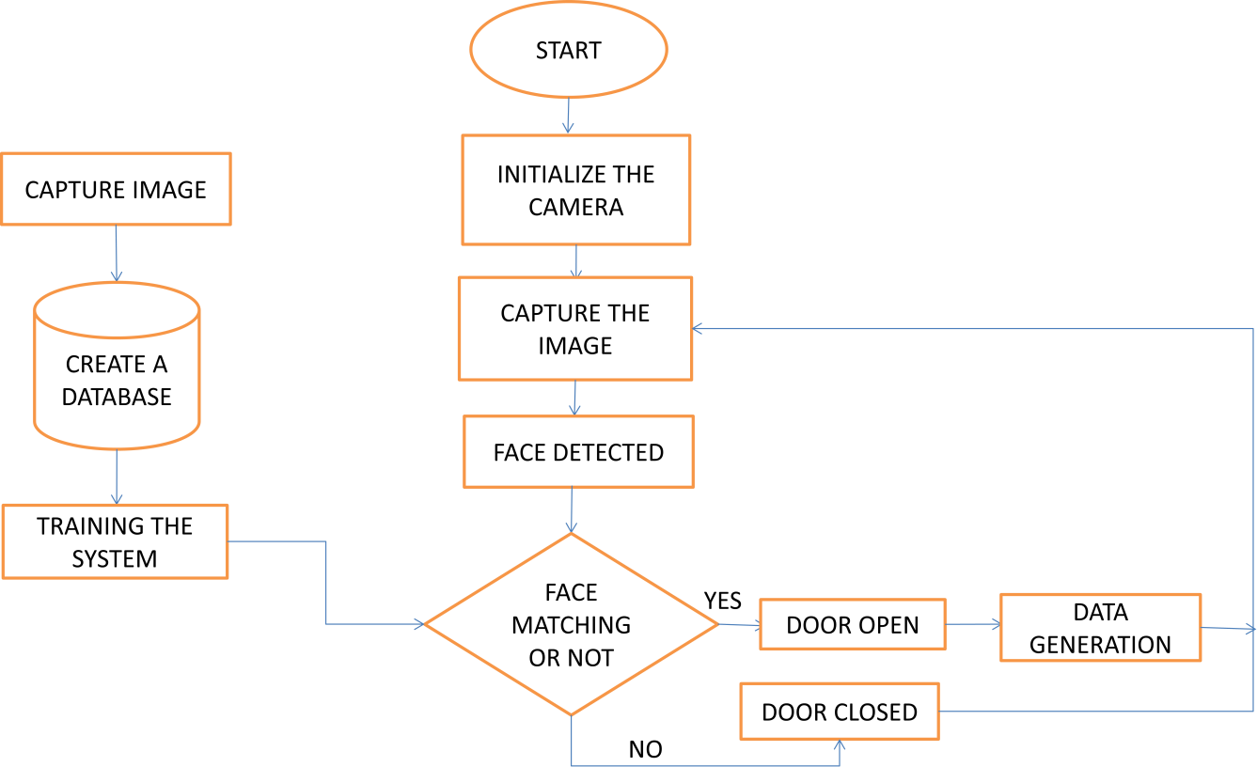
TRAINING OF IMAGE:

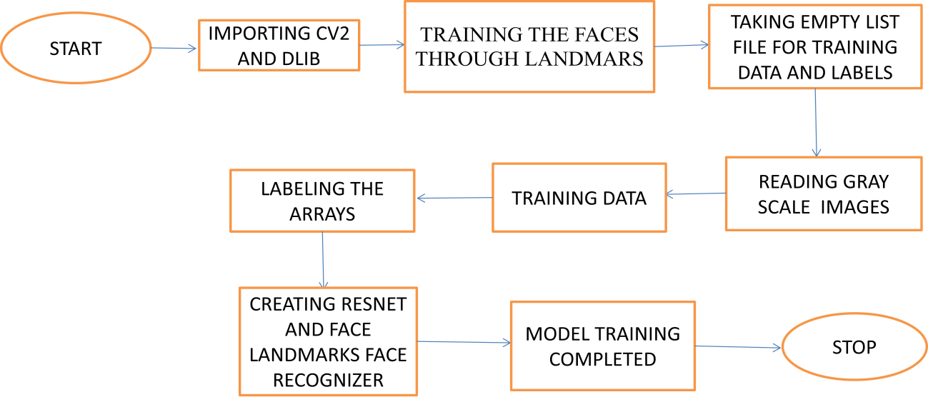

RECOGNITION
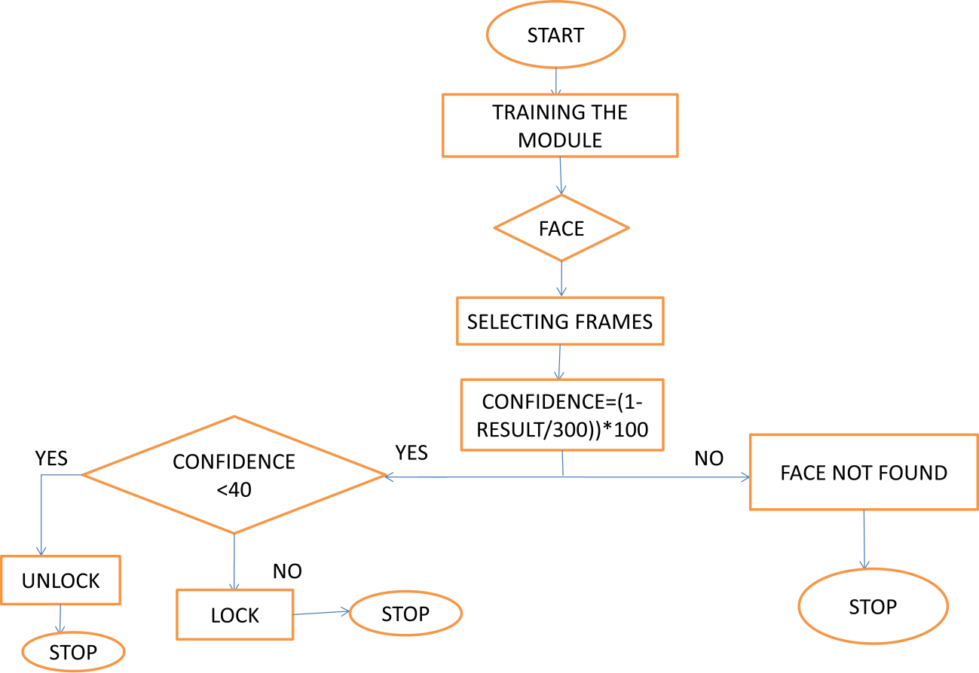
ARCHITECHURE:
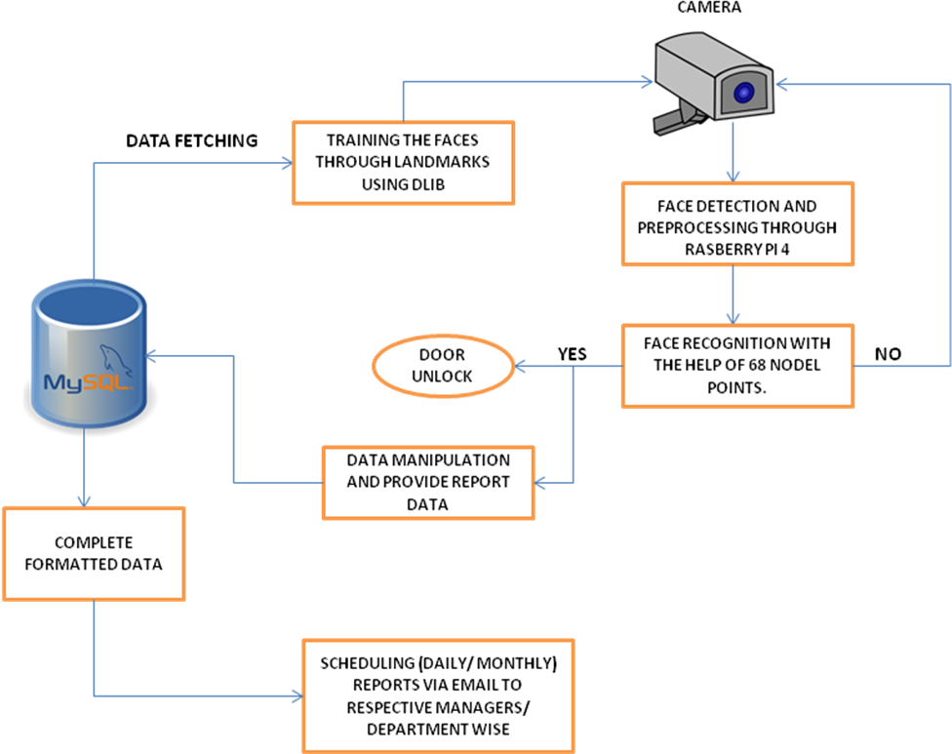

Working procedure: 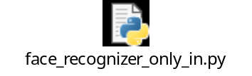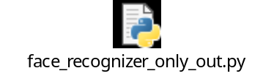

Initially, we need to train a system to recognize the faces and it should be trained with specific faces to unlock the door. To built this we have followed few below steps, is as follows

Step 1: Need to train a model to identify the faces.

To perform this we have taken a sample single image of every person whose face has to be recognized, we store each image in a separate folder to make the system understand that person with the name as a label.

Step 2: Need to make a list with labels of images.

After taking the sample images we will label the images with the person name and we create a dictionary with trained faces label with a unique id where it holds a user name.

Step 3: Need to create a recognizer for facial features.

After training the faces, we have to build a recognizer with the dlib existing modules (resnet and landmarkers). With the help of these modules, it will read an image of individuals and store their values.

Step 4: After finishing the training we will directly apply it to the live video and check how accurate it detecting and recognition of a face.

Step 5: Once the person is been recognized with accuracy. His/her data will be displayed for that particular identified person.

Step 6: Allowing mysql server to be queried from remote host and by creating a user on the mysql server that allows a user from the Pi to connect, we retrieve data.

Requirements: Hardware Requirement:
  - System

  - Camera

  - Raspberry Pi 4

  - Display/Relay

Software Requirement:

  - Python

  - Mysql

Dlib Model:

Detecting facial landmarks is therefore a two step process:

Step 1: Localize the face in the image.

Step 2: Detect the key facial structures on the face ROI.

With the help of Dlib library we are localizing 68 landmark points within a face image. Feature points are such as:
- Points 0 to 16 is the Jaw line
- Points 17 to 21 is the Right Eyebrow
- Points 22 to 26 is the Left Eyebrow
- Points 27 to 35 is the Nose
- Points 36 to 41 is the Right Eye
- Points 42 to 47 is the Left Eye
- Points 48 to 60 is Outline of the Mouth
- Points 61 to 67 is the Inner line of the Mouth

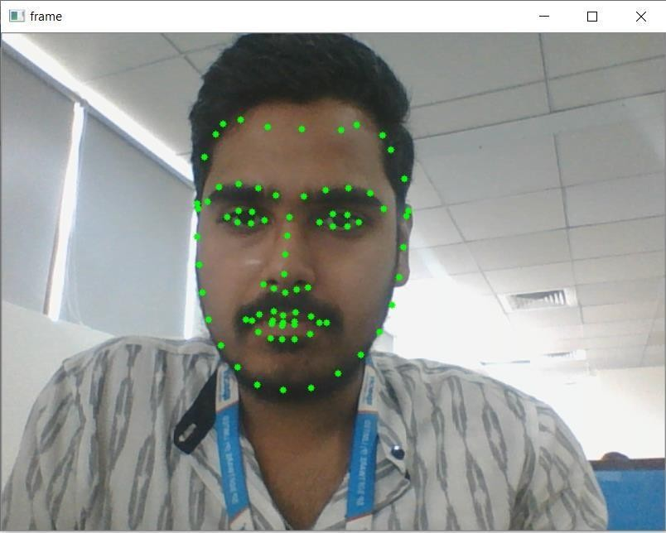

Mounting Angle of Camera:

Face detection algorithm can tolerate up to 45 degrees angle error. Certainly, clear face images will reduce omissions.

Camera Installation:
- Cameras should be installed at Angular direction.
- Camera installation height depends on resolution, typically 1.7 meters.
- Registration: pixel distance between eyes - min 100 pixels
- Recognition: pixel distance between eyes - min 100 pixels
- Detects face typically up to a distance of 3 meters from the camera. The actual distance depends on camera installation height and associated angle of incidence.
- Constant illumination throughout the day (> 200 lux).
- Detection: pixel distance between eyes – min 60 pixels

Horizontal Angle:

The horizontal angle means the angle between camera and horizontal direction of positive direction face. The limit should below 45 degrees. It is recommended not to exceed 30 degrees.
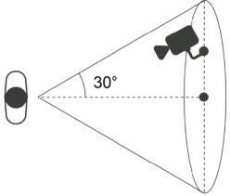

Vertical angle:

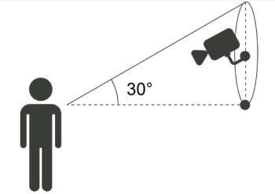
Vertical angle means the angle between camera and vertical direction of positive direction face. The limit should below 45 degrees. It is recommended not to exceed 30 degrees.

Challenges:

Here, these are the challenges which limit the potential of our Facial Recognition System to go that extra mile as these challenges have constantly played with the quality of delivery.
- Illumination:
A slight change in lighting conditions has always been known to cause a major impact on our results, as such detecting and recognition is been difficult.
- Pose variation:
Our system is highly sensitive to pose variations. It only detect when it finds complete face to recognize, side angle face recognition is a bit hard to get close to, due to landmarks.
- Occlusion:
Occlusion of the face such as cap, mask, and shades are also evaluation of a face recognition system. Our system is not detecting or recognizing when a person comes up with handkerchief tied to his face or for some reasons having their face covered with their hands and a person with mouth open.
Person with cap, up to 45 degree of camera resolution the face reorganization doesn’t work.
- Camera:
Based on camera resolution the distance of recognition distance been varying.

Testing Methods:

We tested our system based on different scenarios where detection and recognition are done successfully.
- Tested based on ageing variations through face application.
- Tracking the moving face and recognition is done with in fraction of seconds.
- Even if the eyes are closed, system is been detecting faces.
- Though the person with or without beard and mustache appearance faces are recognized.
- Depending on camera specification, the distance of detection and recognition is varying.
- Through streaming source, faces are recognized.
- Within a frame, multiple faces are been recognized.
- Photo picture and phone picture with faces are detected.
- Camera angle of detection, from the top it is up to 45 degrees and from the bottom angle with 30 degrees.

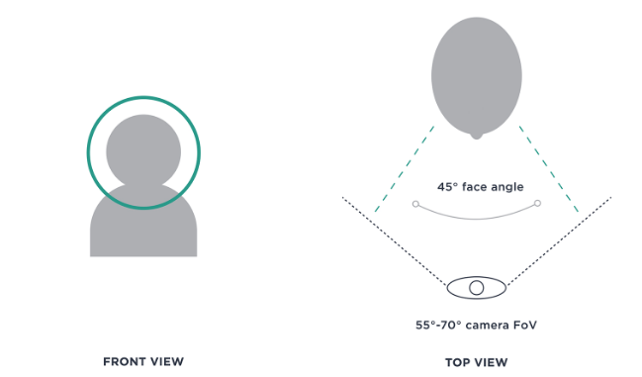

INSTALLING PROCESS:

DOWNLOADING THE RASPBIAN OS:

Here’s how to get the Raspbian os onto your SD card:

Head on over to the official BusterOS download page and start your download.

“Raspbian Buster with Desktop and recommended software”.

Download Balena Etcher — software for flashing memory cards. It works on every major OS.

Use Etcher to flash BusterOS to your memory card.

After downloading the Raspbian Buster .img file you can flash it to your micro-SD card using Etcher

After a few minutes the flashing process should be complete — slot the micro-SD card into your Raspberry Pi 4 and then boot.

At this point, you have an SD card loaded with the Raspbian os.

PLUGGING EVERYTHING IN:

Plug in a mouse and keyboard to the USB ports.

Plug in a monitor using an HDMI cable.

Plug in an Ethernet cable to the network port and make sure the other end is plugged into your router.

Finally, plug in the MicroUSB power cord.

FIRST BOOT AND USER ACCOUNT CONFIGURATION:

The first time the Raspbian os boots, you have to go through the standard Linux new user process. You select the type of keyboard you are using, create a user account and pick a password. When you are done, you’ll see a blank Linux desktop.

At this point, Python 3.7 and OpenCv are already installed. You can open up a terminal window and start running Python programs right now just like on any other computer. But there are a few more libraries that we need to install before we can run our Face recognition system.

EXPAND FILESYSTEM AND RECLAIM SPACE:

You have an SSH or VNC connection established with your Pi. Alternatively, you could use a

Keyboard + mouse + screen.

Go ahead and insert your microSD into your Raspberry Pi and boot it up.

Once booted, configure your Wi-Fi/Ethernet settings to connect to the internet (you’ll need an internet connection to download and install required packages for OpenCv).

From there you can use SSH or go ahead and open a terminal.

INSTALLING REQUIRED PYTHON LIBRARIES:

To build our face recognition system, we need to install several Python libraries.

From the Raspbian desktop, open up a Terminal window and run the supportive commands.

SQL SERVER INSTALLATION:

Click on 'setup' application and Click on Installation

Click on “Add Current User” and click Next button.

After installation, Click Start and type “ssms” and press enter.

The first time you run SSMS, the Connect to Server window opens. If it doesn't open, you can open it manually by selecting Object Explorer > Connect > Database Engine.

Click on “Connect” to connect to the server

Into the query window, paste the following T-SQL code.

Create database test_dataview and click on execute or press F5.

In the database drop-down list, select the database that you want to use, as shown here. Or “USE” is the command to switch to the required database.

REPORTING SYSTEM: 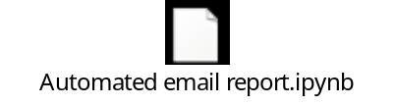

Once the face recognized, the employee data will be stored in Mysql where data get fetched with required manipulations and save the report in the csv format.

Generated csv file of employee data will be emailed to respective reporting managers.

OUTPUT:

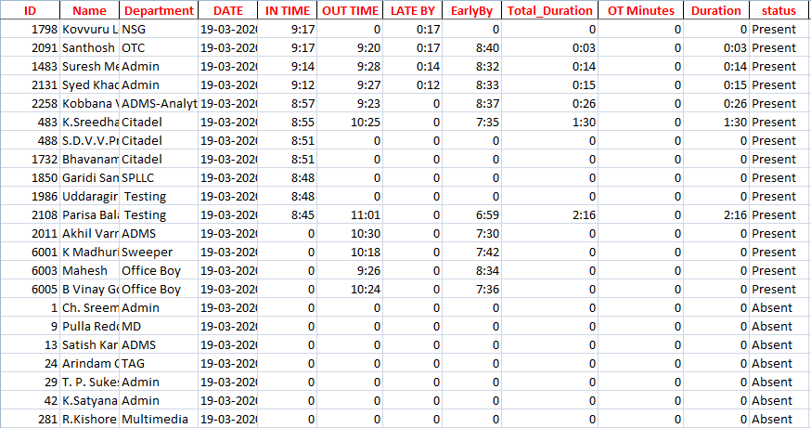

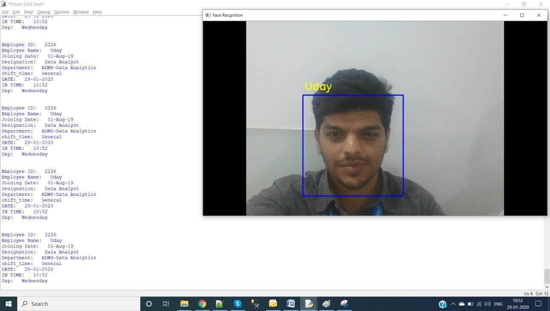

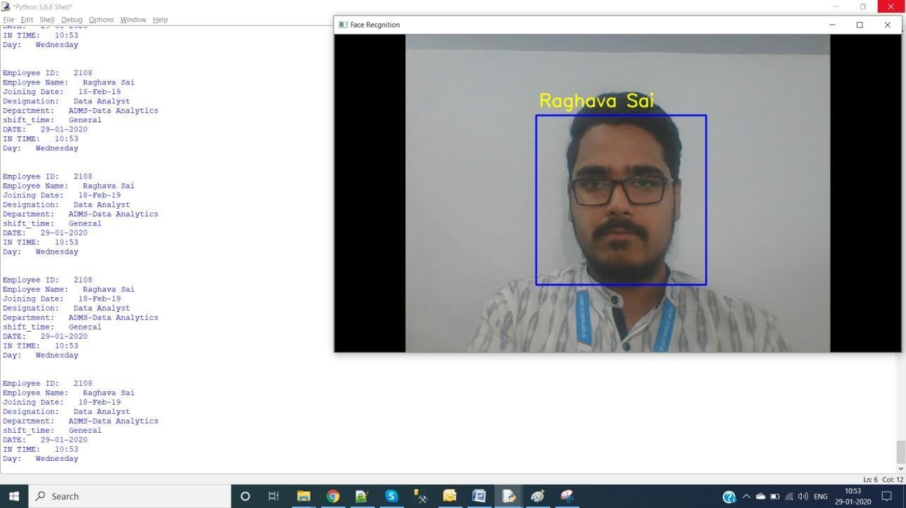
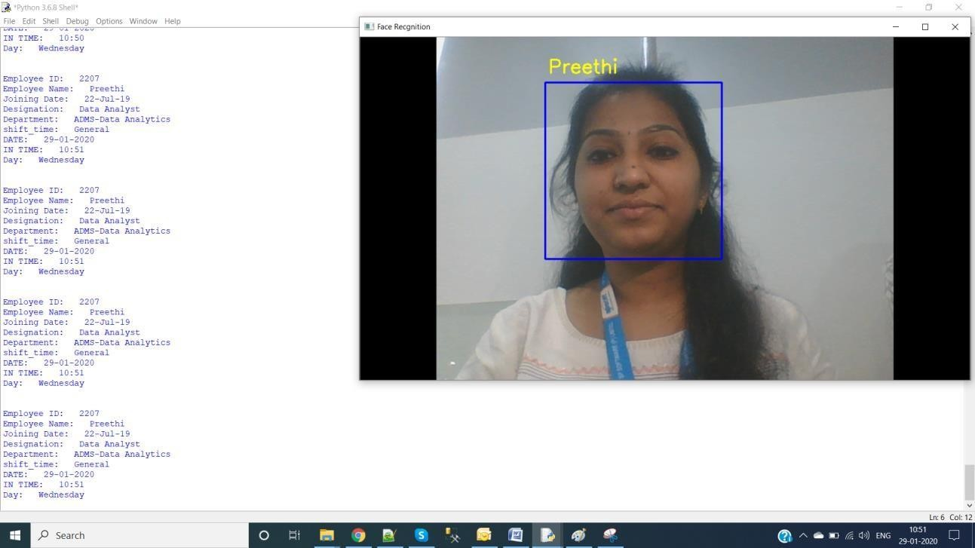

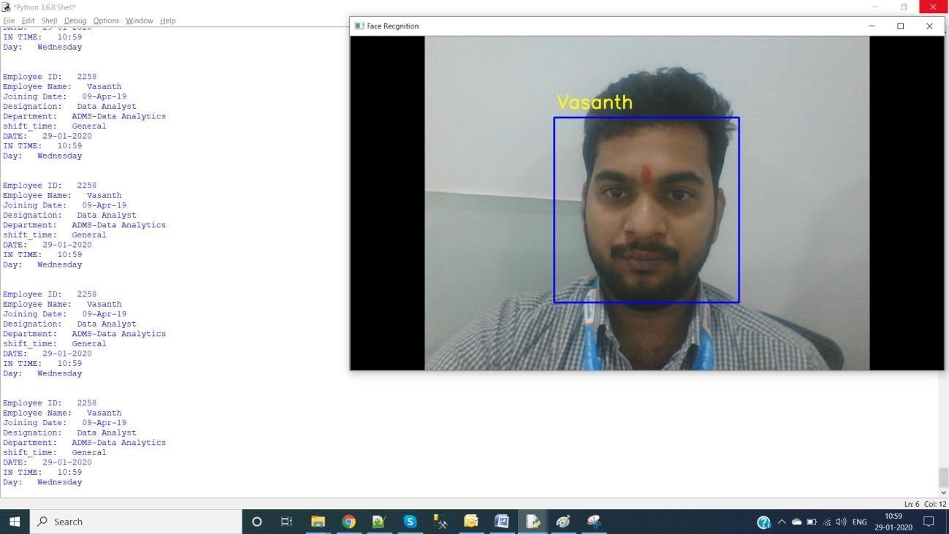
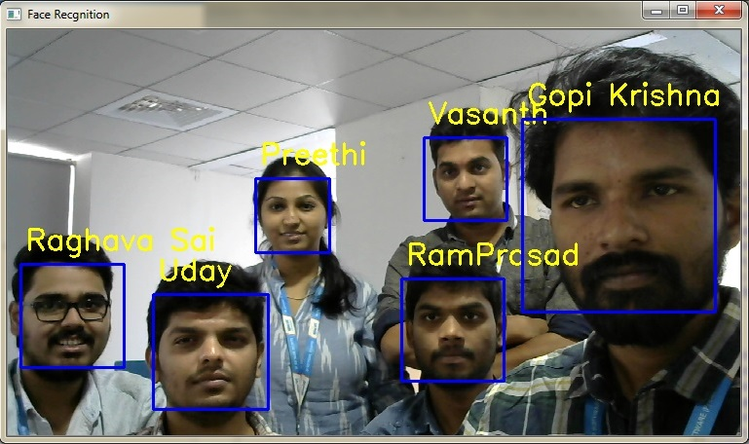

CONCLUSION:

In this proposed door access system by using face recognition the images are stored in a data base. This system is used door lock access for an Organization. Here we have designed a highly secured door locking system by using Opencv and Dlib libraries.

FUTURE SCOPE:

Using the current project can be modified by an Infrared camera interfacing it can be used in Smart Surveillance Monitoring security system which any type of public security is using Living body detection or spying. Also some profound applications can be implemented using interfacing of sensor application of smartcard swapping, finger detection, alcohol detection, agriculture humidity sensing, Temperature sensing using web server, and many more.

The general experimental evaluation of the face expressional system guarantees better face recognition rates. Having examined techniques to cope with expression variation, in future it may be investigated in more depth about the face classification problem and optimal fusion of color and depth information. Further study can be laid down in the direction of allele of gene matching to the geometric factors of the facial expressions. The genetic property evolution framework for facial expressional system can be studied to suit the requirement of different security models such as criminal detection, governmental confidential security breaches etc.

